**Subject: Advanced C concept.**

**This program is written by Souravsing Pardeshi.**

**Practical no. 1.**

**Date:26/7/2019.**

#include<stdio.h>

#define UPPER(x) (x>=65 && x<=90)

#define LOWER(y) (y>=97 && y<=122)

#define ALPHABATE(z) (z>=65&&z<=90 || z>=97&&z<=122)

#define BIGGER(a,b) (a>b)

int main()

{

int i,a,b;

char x,y,z;

printf("\n Enter yur choice");

printf("\n1: to test the character is lower case letter or not");

printf("\n2: to test the character is upper case letter or not");

printf("\n3: to test the characte is alphabate or not");

printf("\n4: to test the character is lower case letter or not");

printf("\n\nchoice:");

scanf("%d",&i);

switch (i)

{

case 1:

printf("\nEnter any character\n");

scanf("%s",&y);

if (LOWER(y))

printf("\nThe given character is lower case letter");

else

printf("\nThe given character is not lower case letter");

break;

case 2:

printf("\nEnter any character\n");

scanf("%s",&x);

if(UPPER(x))

printf("\nThe given character is upper case letter");

else

printf("\nThe given character is not upper case letter");

break;

case 3:

printf("\nEnter any character\n");

scanf("%s",&z);

if(ALPHABATE(z))

printf("\nThe given character is alphabate");

else

printf("\n The given character is not alphabate");

break;

case 4:

printf("\nEnter the two values\n");

scanf("%d,%d",&a,&b);

if(BIGGER(a,b))

printf("\nThe bigger value is %d",a);

else

printf("\nThe bigger value is %d",b);

break;

default:

printf("\n\n INVALID \n");

}

return 0;

}

Output of above program is:

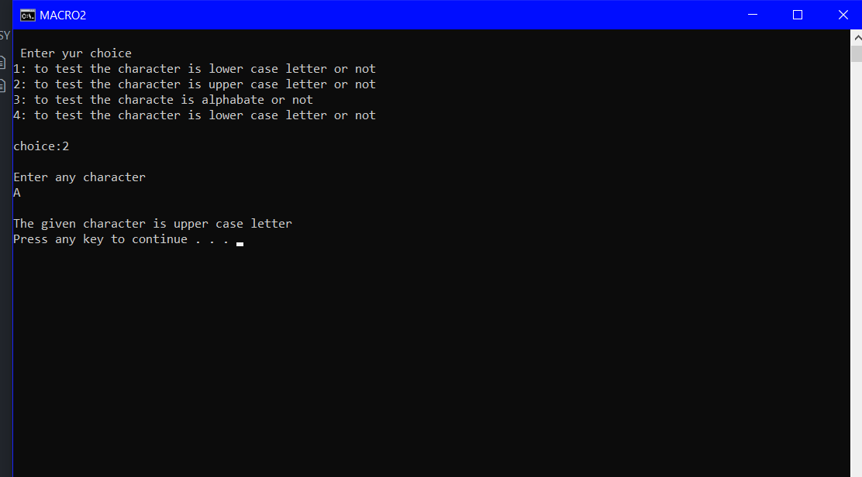

**This program is written by Souravsing Pardeshi.**

**Date:29/07/2019. Practical No.:2.**

**THE HEADER (areaperi.h)FILE IS CODED AS:**

#include<stdio.h>

int i,b,h,a,r,t,c,j,s,p=3.14;

#define AREATRIANGLE(t) ((b*h)/2)

#define AREASQUARE(s) (a*a)

#define AREACIRCLE(c) ((r*r)*p)

#define PERITRAI(x) (b+h+a)

#define PERISQ(y) (4*a)

#define PERICI(z) (2*p*r)

**The main program can be written as follows where the areaperi.h file is included.:**

#include<stdio.h>

#include"areaperi.h"

int main()

{

printf("press 1 for area of traingle\n");

printf("press 2 for area of square\n");

printf("press 3 for area of circle\n");

printf("press 4 for perimeter of traingle\n");

printf("press 5 for perimeter of square\n");

printf("press 6 for perimeter of circle\n");

printf("enter your choice");

scanf("%d",&i);

switch(i)

{

case 1:

printf("enter the base and height\n");

scanf("%d",&b);

scanf("%d",&h);

AREATRIANGLE(t);

printf("\n area of traingle=%d",AREATRIANGLE(t) );

break;

case 2:

printf("\nenter the sides\n");

scanf("%d",&a);

AREASQUARE(s);

printf("\narea of square=%d",AREASQUARE(s));

break;

case 3:

printf("\nenter the radius");

scanf("%d",&r);

AREACIRCLE(c);

printf("\narea of circle=%d",AREACIRCLE(c));

break;

case 4:

printf("\nenter the three sides\n");

scanf("%d,%d,%d",&b,&h,&a);

PERITRAI(x);

printf("\nperimeter of traingle=%d",PERITRAI(x));

break;

case 5:

printf("\nenter the side of square\n");

scanf("%d",&a);

PERISQ(y);

printf("perimeter of squre=%d",PERISQ(y));

break;

case 6:

printf("enter the radius of circle");

scanf("%d",&r);

PERICI(z);

printf("\nperimeter of circle=%d",PERICI(z) ) ;

}

Return 0;

}

**Output of above program can be written as:**

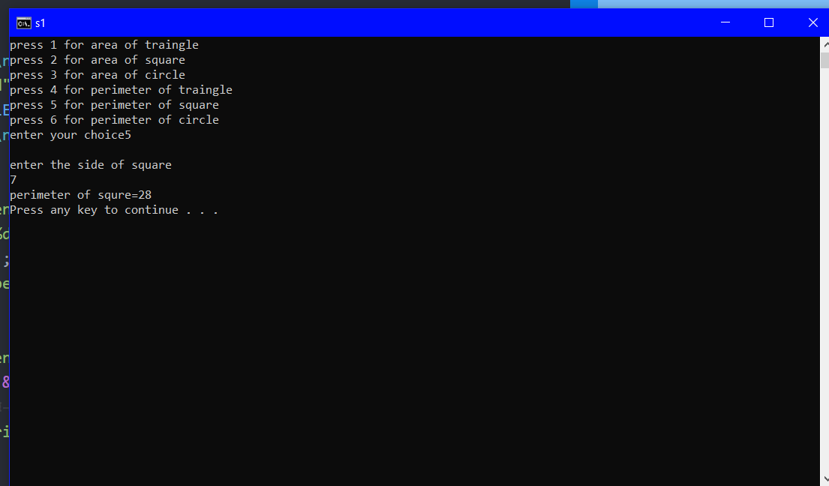

**This program is written by Souravsing Pardeshi**.

**Date :2/08/2019 Practical no. 3 :Storage classes**

#include<stdio.h>

#include<conio.h>

int main()

{

int i;

auto int l=1;

register int j=1;

static int k=1;

printf("\n\tEnter which storage class you want to see\n");

printf("\tenter 1 for checking auto storage class\n");

printf("\tenter 2 for checking registor storage class\n");

printf("\tenter 3 for checking static storage class\n");

printf("\tenter 4 for checking extern storage class\n");

scanf("%d",&i);

switch(i)

{ case 1:

for(l=1;l<=1;l++)printf("\n\tyou are in auto storage class\ni=%d",i);

break;

case 2:

for(j=1;j<=1;j++)printf("\n\tyou are in register storage class\nj=%d",j);

break;

case 3:

for(k=1;k<=1;k++)printf("\n\tyou are in static storage class\nl=%d",l);

break;

}

return 0;}

**Output of above program is:**

